THE USE OF GEOTHERMAL ENERGY FOR A MORE SUSTAINABLE FUTURE IN GENERAL

Key words: geothermal energy, sustainability, low carbon footprint emissions

The nine students of SŠGT Maribor are doing their 3-week-Erasmus practice in hotels and restaurants in Reykjavik, Iceland, from 13th June to 4th July, 2026.
On the 25th of June, 2026 our nine students visited the Hellisheidi Geothermal Power Plant, an hour drive from Reykjavik. The trip was very interesting and educational, because we do not have such energy plants in Slovenia.
Namely, almost the whole Reykjavik gets hot water and eco-friendly energy from the Hellisheidi Geothermal Power Plant. 40% of obtained energy is used for electric generation, 43% for space heating, 4% for swimming-pools and bathing, 9% for agriculture, aquaculture, industry, and 4% for other uses.
The Hellisheidi Geothermal Power Plant has six high-pressure turbines, as well as one low-pressure turbine. Hot steam from boreholes drives the turbine that spins around 3000 rpm. The turbine axle is connected to a generator that generates electricity.
The interesting fact is, that the extracted gases of the Power Plant are dissolved in the disposal water of the plant and reinjected into the earth. Carbon dioxide accounts for 0.3% of the geothermal liquids that go into the Plant, but by mixing it with water, just like the mineral water is created, and pumping it into basaltic bedrock, the carbon dioxide is transformed into rock, becoming a mineral called calcite. The hydrogen sulphide turns into pyrite and is often called fool’ s gold because of its resemblance to gold.

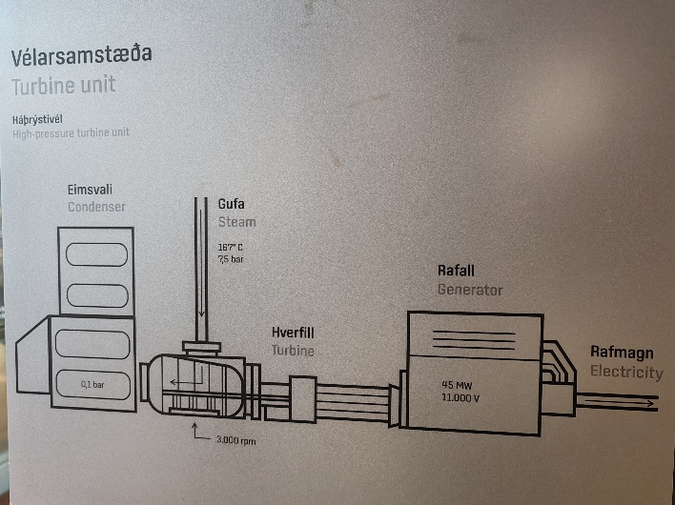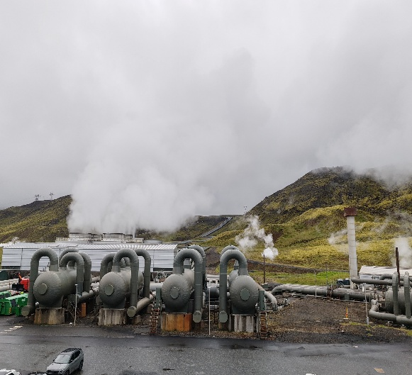

In conclusion, each country should try and use its eco-way of getting the energy with minimum carbon footprint emissions.

Snježana Ris Primec, prof. at SŠGT Maribor
Slovene GreenHost coordinator

